### GOVERNMENT ARTS COLLEGE,DHARMAPURI636705.

## DEPARTMENT OF ELECTRONICS & COMMUNICAION

#### AFFILIATED TO PERIYAR UNIVERSITY 2023-2024

#### NAAN MUDHALVAN PROJECT REPORT

#### Submitted in Partial Fulfilment of the Requirements for Degree

## of

## B.Sc., ELECTRONICS & COMMUNICATION

## Submitted to

## Periyar University, Salem-636 011

# By

#### SAFIULLAH B

#### VIKRAM K

#### SIVAKUMAR S

#### MUTHAMILSELVAN M

## ESTIMATION OF BUSINESS EXPENSES

#### This report delves into the fascinating realm of business expenses and provides a visual exploration of the various expenditures incurred by different businesses.

#### It showcases the distribution of expenses, identifies key cost drivers, and highlights areas of potential optimization or concern. The visual representations allow for intuitive analysis, facilitating a deeper understanding of expenditure patterns and their implications for business performance.

#### Decision-makers, financial analysts, and stakeholders can gain valuable insights into the financial health of businesses, identify areas of inefficiency or opportunity, and make informed decisions to optimize resources and drive growth.

#### To Extract the Insights from the data and put the data in the form of visualizations, Dashboards and Story we employed Tableau tool.

## PURPOSE

#### The technical architecture involves leveraging the data analytics capabilities of Tableau for visualizations and analysis. The architecture comprises several components to ensure efficient data processing and visualization.

#### At the core of the architecture is the data infrastructure, which includes data sources such as market reports, economic indicators, and surveys conducted among iPhone users in India. These data sources are collected and stored in a structured format for further

#### analysis. Tableau is used as the primary data visualization tool. It connects to the data sources and allows for data extraction, transformation, and loading (ETL) processes. Tableau's intuitive interface enables users to create interactive and visually appealing visualizations, charts, and dashboards based on the analyzed data.

## RESULT:

## EMPATHY MAP

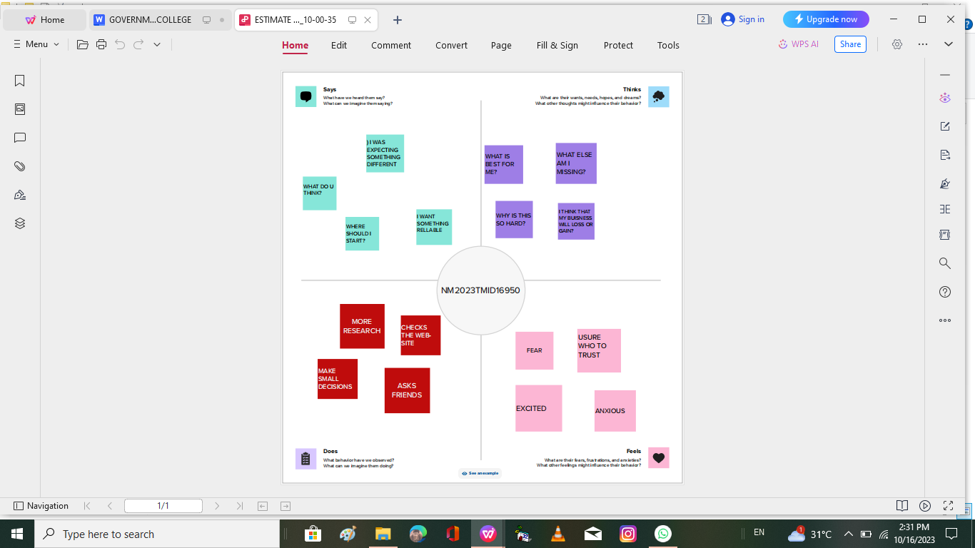

## BRIAN STORM MAP

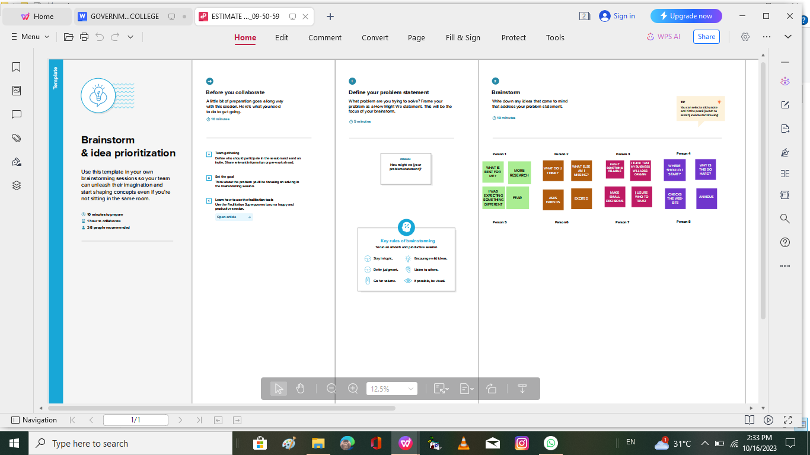

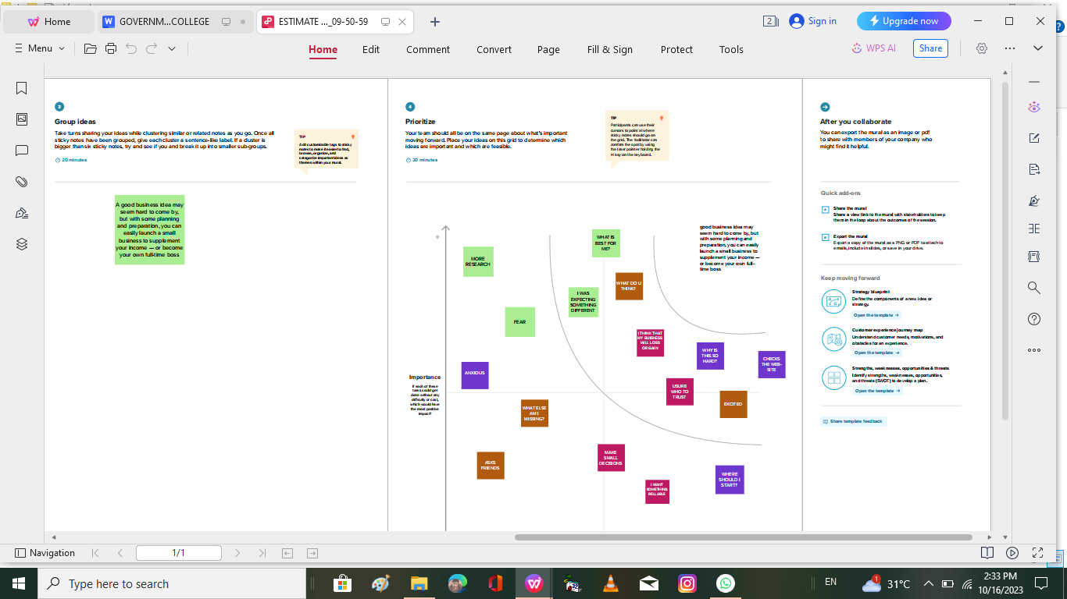

## RESULT :

##### FINAL FINDINGS (OUTPUTS) OF THE PROJECT ALONG WITH SCREENSHOTS.

## 1.DASHBOARD

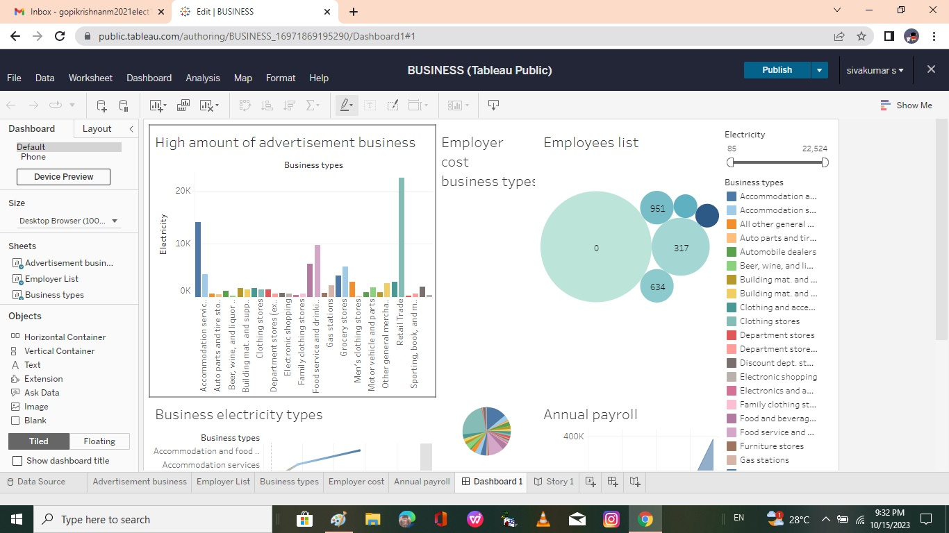

## 2.STORY

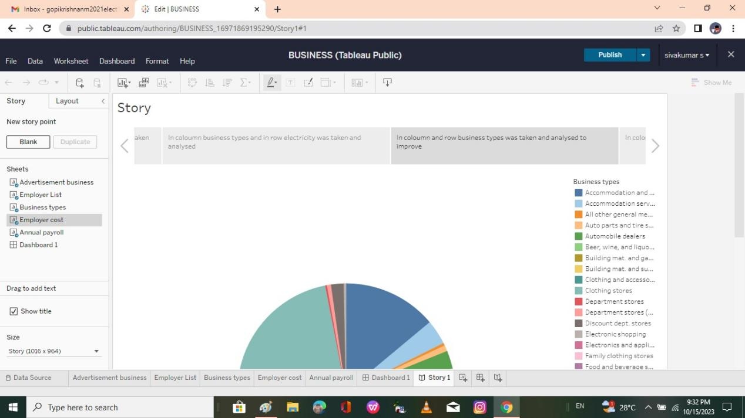

## ADVANTAGES :

##### You will know exactly how much money is available to run your business and you will not have to spend time trying to secure other forms of funding from investors or banks.

##### Self-financing your business gives you much more control than other finance options. It also means that you don't need to pay back or rely on outside investors or lenders, who could decide to withdraw their support at any time.

##### You will retain full ownership of the business, which in turn means that you will receive 100 per cent of future profits.

##### If you fund a business yourself, you will be forced to live within your means, only investing in business equipment and marketing when you need to. This can help you to prioritise your business expenditure and avoid excessive spending.

## DISADVANTAGES :

#### Using your own money to finance your business may put a strain on your family and personal life. You may not have enough money left over to cover your living costs. You should try to leave a contingency fund, in case you need extra money to see you through a difficult period.

#### If your business were to fail, you could lose your home and other personal possessions.

#### Many investors and venture capitalists can also provide mentoring and networking opportunities for you and your business - if you fund your business alone, you will have to develop your own contacts and mentoring opportunities.

## CONCLUSION :

Research must focus on how Apple's iPhone has affected business in India. We seek to examine theeconomic effects of iPhone uptake in the Indian market using data analytics and Tableau visualizations.

#### Examining iPhone sales data, market share, revenue creation, and its **effects on different industries like e-commerce, app development, and** digital payments are all part of this. Organizations can find possibilities for growth and innovation by understanding the business impact and using it to help them position themselves in their markets and make strategic decisions.

## FUTURE SCOPE :

#### Through this program, training modules in coding and robotics will also be provided. In addition, psychological counselors and medical physicians will provide guidance on the student's nutrition, physical fitness, and overall personality development

# THE END